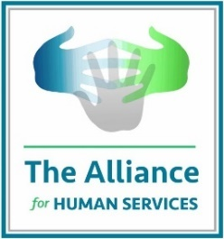 Access To Resources Fund
Guidelines

The Alliance for Human Services is a membership organization composed of Lake County leaders including human, health, and education service organizations; foundations; and government officials and entities. The Alliance provides several forms of resources to members throughout the County to aid in breaking down silos, supporting service workers and organization/county leaders, and amplifying the voices of the sector and those served. The Alliance offers annual membership dues on a sliding scale to encourage the participation of all Lake County leaders in the sector. To further support participation, the Alliance is raising funds through the Access to Resources Fund for stipends for organizations that can’t afford full membership. Fund guidelines are:

- Preference for newly formed organizations and organizations that are new to Lake County.

- Preference for organizations whose revenue was disproportionally affected by the pandemic

- Preference for organizations with smaller budgets both overall and small for that organization’s category.

- Preference for organizations that diversify the voices of the Alliance including:
  - Grows the representation of communities (including but not limited to race, ethnicity, gender, and age)
  - Expands the geographic areas the Alliance’s members covers, and/or
  - Increases the types of needs and services members amplify.

- Preferences for members who have social service staff that lack connectivity to colleagues who provide similar services, or for organizations with new leadership.

- Preference for organizations that have not been members in the past.

- Preference for organizations that articulate a desire to want to participate in the Alliance’s events and activities.

- Organizations should
  - Pay a portion of the membership.
  - Articulate the reason it needs the stipend and a plan with specific timing when it will be able to afford full membership.

- The Alliance will consider a multi-year plan if the amount of the subsidy decreases from year to year and the plan is reasonably and fully articulated in the request.

Membership dues are determined by the:
- Size of the budget for Lake County activities
- Budget funding the organization and its activities, not for funds distributed directly to individuals and families in the community.

All interested in participating in the Alliance but are unable to afford membership are encouraged to fill out the Fund Application. For more information or questions, please reach out to Gayle at gayle@allianceforhs.org

